2019 – 1 HOWELL AREA HISTORICAL SOCIETY SPRING EDITION

The caboose looks a lot different in 2018 from when the Museum acquired it in 2012, doesn’t it? There has been a monumental amount of work and pride put into it since the day that it arrived. So many people have donated their time and expertise to make the caboose what it is today. That’s the same story of the Depot.

When the Historical Society purchased the Depot in 1968, it was a mess. It had been used for storage by the Ann Arbor Railroad for a long time. The intrepid volunteers set to work, and, cleaned the building 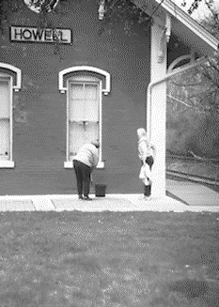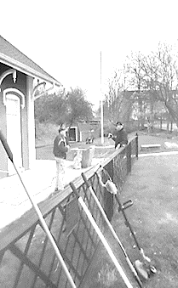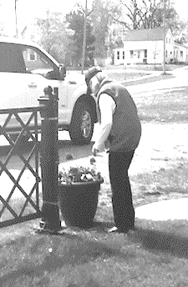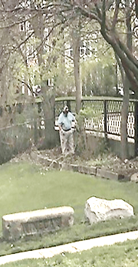 until it shone. The volunteers of 2019 are attempting to fill those shoes. Our Board has been working hard to get the inside and outside ready for the 2019 season. See the above photos of our May 4 cleanup day.

President’s Note

What does the Depot complex mean to you? How did you first get involved? What was your first memory of the Depot/Museum or the caboose? Did you ride the last passenger train departing from the Depot in July, 1950 as a very young child? Did you received yoour first kiss on the bridge over the tracks overlooking the Depot? Did you come here in a school tour as a child? Were you here on the caboose for a “Scary” story during “The Legend of Sleepy Howell?” Is there a brick on the grounds that you purchsed in memory of your grandparents who instilled a love of history in you? Or, maybe you only recently learned of our beloved Depot Museum after your child went on a school tour, and came home talking your ear off about the big red caboose. Whatever your connection to this place, how old or new, we hope it is as imporatant of a place to you as it is to us.
We would love to have you join (or rejoin) the Society. We do not receive any funds from the city or state. We rely on our members, and, mainly, small contributions from visitors, and Melon Fest to sustain us throughout the year.
Whether it be to help to sell water during MelongFest, weed flowerbeds, paint things, or just come visit on a Sunday, we’d love to have you stop by. You will learn more about our 1886 Ann Arbor Railroad Depot, or you can help with the continuing restoration of our 1888 Grand Trunk Western caboose.
Young or old, it doesn’t matter. If you share a common appreciation for local history, we’d love to have you.
“Rudy” Rudolph

RAILROAD NEWS
BIG BOY COMES TO LIFE TO CELEBRATE THE GOLDEN SPIKE 150TH ANNIVERSARY OF THE TRANSCONTINENTAL RAILROAD

Twenty-five Big Boys were built exclusively for Union Pacific Railroad. The first of which was delivered in 1941. The locomotives were 132 feet long and weighed 1.2 million pounds. Because of their great length, the frames of the Big Boys were "hinged," or articulated, to allow them to negotiate curves. They had a 4-8-8-4 wheel arrangement, which meant they had four wheels on the leading set of "pilot" wheels which guided the engine, eight drivers, another set of eight drivers, and four wheels following which supported the rear of the locomotive. The massive engines normally operated between Ogden, Utah, and Cheyenne, Wyo.
There are seven Big Boys on public display in various cities around the country. They can be found in St. Louis, Missouri; Dallas, Texas; Omaha, Nebraska; Denver, Colorado; Scranton, Pennsylvania; Green Bay, Wisconsin; and Cheyenne, Wyoming.
Big Boy No. 4014 was delivered to Union Pacific in December 1941. The locomotive was retired in December 1961, having traveled 1,031,205 miles in its 20 years in service. Union Pacific reacquired No. 4014 from the RailGiants Museum in Pomona, California, in 2013, and relocated it back to Cheyenne to begin a multi-year restoration process.
Vital Statistics
Tender Type: 14-wheeled
Water Capacity: 24,000 gallons
Fuel: Coal**
56,000 lbs.
Gauge of Track: 4 ft. 8-1/2 in.
Cylinder: Diameter: 23 3/4 in.
Stroke: 32 in.
Driving Wheel Diameter: 68 in.
Boiler: Outside Diameter: 106 9/16 in.
Pressure: 300 lbs.
Fire Box: Length: 235 1/32 in.
Width: 96 3/16 in.
Tubes: 2-1/4 in. Diameter: 75 x 22 ft. 0 in.
4 in. Diameter: 184
Wheel Base: Driving: 47 ft. 3 in.
Engine: 72 ft. 5 1/2 in.
Engine & Tender: 132 ft. 9 7/8 in.
Weight in Working Order,
Pounds: Leading: 97,000
Driving: 540,000
Trailing: 125,000
Engine: 762,000
Tender: 427,500
Evaporating Surfaces,
Square Feet: Tubes: 967
Flues: 4,218
Fire Box: 593
Circulators: 111
Total: 5,889
Superheating Surface,
Square Feet: 2,466
Grate Area: 150
Maximum Tractive Power: 135,375 lbs.
Factor of Adhesion: 4.00
**Previous configuration. Now converted to No. 5 Oil
Bringing the Big Boy Back to Life
Dare to compare ...

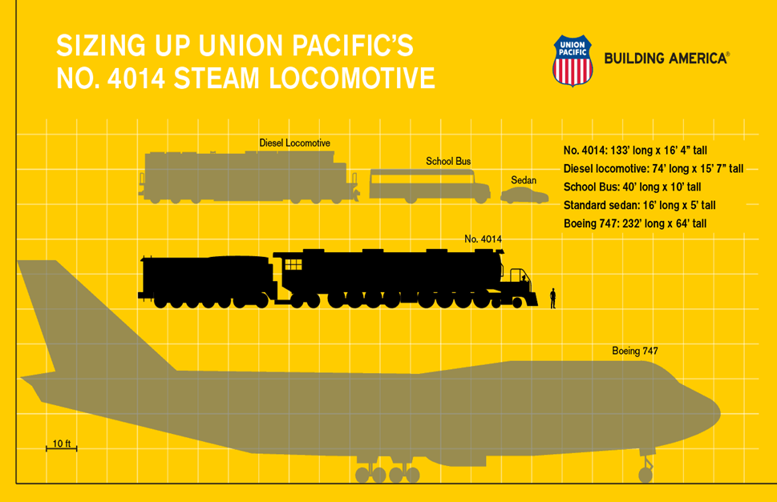

You can renew your membership, purchase a “This Place Matters” brick, drop us an email, sign up as a volunteer, or make a donation online at www.howellareahistoricalsociety.org

You can donate to the Museum by using your Kroger charge, and specify the Depot as your charity.
Please use Amazon Smile with the Depot Museum as your charity.

The
Howell Area Historical Society is a 501©3 non-profit organization. Your donation is tax deductible

Please visit our website at howellareahistoricalsociety.org to donate, volunteer, or just to see what we are about.

HOWELL HAS HISTORY

Don Maiolatesi
It was seven years ago that we moved our family to Howell. We virtually knew nothing about this little city. But in a short period of time, we learned a lot about its history while we simultaneously fell in love with it. We moved from Troy, Michigan. Certainly, Troy is a very nice city, but very busy and congested. Howell, on the other hand, has its Uptown area filled with original buildings and friendly people. That was certainly a breath of fresh air to us.
We joined the Howell Area Historical Society. First it was my wife, who became the Secretary. A very short time later, I assumed the position of Treasurer. Volunteering for these two positions projected us into having to learn more about the Depot and its corresponding history.
Although the building is the old railroad station built in 1886, the inside is filled with artifacts and items representing the growth of Howell. The inside items are both railroad related as well as non-railroad artifacts.
Set adjacent to the Depot is the 1888 caboose. After much work performed by other members of the Board, and certainly much of which was completed prior to our arrival, the caboose has been rehabilitated to its near original creation.
The Depot and Caboose are open every Sunday from 10 am to 2 PM in conjunction with the Howell Farmers’ Market. The viewing is from the first Sunday in May through the last Sunday in October, except during holiday weekends.
Although there are other areas of Howell filled with history, the Depot and adjacent caboose are one small piece that will give you a flavor of the history of this wonderful city.
Please join us to view a piece of Howell history. You will enjoy it.
Howell Area Historical Society
128 Wetmore Street
Mailing Address P.O. Box 154 Howell, Michigan 48844
howellareahistoricalsociety@gmail.com

517-548-6876

For Wedding or Tour Information, ask for Mary

For all of you car enthusiasts, the Depot Car Show will be held on August 17, 2019 during MelonFest

Contact Don Maiolatesi at 517-548-6876, or 517-294-3163 for information

SPECIAL THANKS
The Howell Area Historical Society would like to thank the Robert W. and Maxine C. Parker Foundation for its generous donation to the Depot Museum. The gift from the Foundation enabled the Society to replace its twenty-five- year old furnace and air conditioner with a new HVAC system. The historic collections in the Museum require a certain amount of climate control in order to preserve them for future generations. We are most grateful for this timely, and much-appreciated gift from the Parker Foundation.

Thank you to Spirit of Livingston (Carol and Danny) for printing this newsletter. Spirit is THE destination for varsity jackets, trophies, shirts, hats, awards, printing, and many, many other products. The store is located at 3280 W. Grand River in Howell.

Thank you, also, to Bramlett Heating and Cooling for their speedy and efficient installation of our new HVAC system.
Thank you to First National Bank for its totally unexpected, but very much appreciated donation to the Depot. We are so thankful for their generosity. Sponsors such as the Bank enable us to continue our work of preserving the past for the future.

MUSEUM VISITING HOURS
Call 517-548-6876 for private tours
The Depot and caboose will be open from May 5, 2019 to October 27, 2019 each Sunday, except for major holidays, from 10:00 a.m. to 2 P.M.

For wedding info, contact Mary at 517-548-6876

2019 Board of Directors
President: Rudy Rudolph
Vice President: Mike Mason
Secretary Mary:Shaughnessy
Treasurer Don: Maiolatesi
Trustee: Gerri Moen
Trustee: Ed Vitez
Trustee : Ed Grima
Please consider joining today.
Call Mary at 517-548-6876 for information.
$15.00 Individual, $25.00 Family

SUFFRAGETTES

It’s unfathomable to realize that women did not always have the right to vote in this country.
Prior to 1920, women could vote in only a few states, and, then, only in school, or other local elections. The ladies were considered too flighty to vote with any intelligence. They were not free citizens at that time, either. They could not own property, or have their own money, if married. It belonged to their husbands, as soon as the wedding was over. The married women could not inherit, also. The husband would have been the beneficiary, not the wives, even if the inheritance came from her family. As you can see, it was an uphill battle that the Suffragettes entered into.
The Suffragettes campaigned for equality, prohibition, and the right to vote. Unfortunately, prohibition was not too popular with most men, so, there was a problem immediately. Some of the suffrage leaders realized this, and changed their platforms.
We have a lot to thank those ladies, and some men, for all that they did to change the voting laws in this country. The women endured jail, beatings, derision, and hate for quite a few years. They did not give up, though. In fact, they had a convention in Seneca Falls, N.Y. in 1848 to mobilize. They marched outside of the White House for many Sundays, much to President Wilson’s disgust. After a while, though, he came to a decision to support the protesters. The First World War was taking the young men away, leaving a need for the women to fill the vacant jobs. President Wilson belatedly realized that the women were crucial to the War effort, and the economy. In the end, money talked.

Where did Michigan Stand?

We can be proud of our state, because Michigan had already allowed women to vote in state and local elections. The fine men of Michigan voted in 1918 to grant the right to vote to the women. Michigan was also the second state in the Union to vote for the 19th Amendment in 1920. Way to go Michigan!

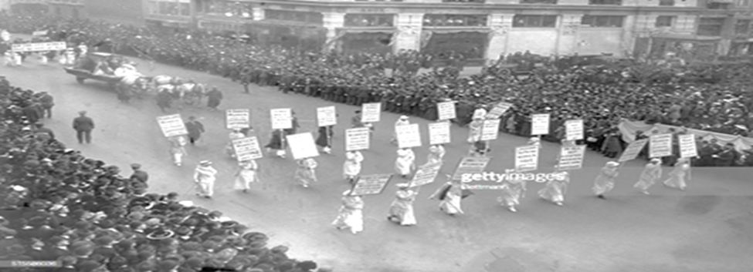

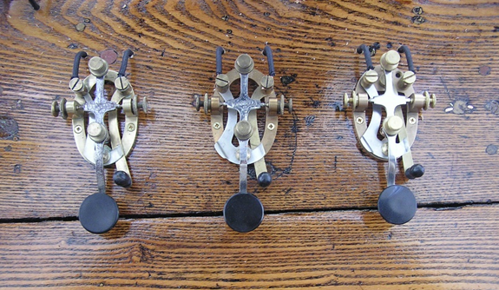

Something New at The Depot?

The long lost “Railroad Telegraph Station” from the Station Master’s Desk has been replaced with a re-constructed one that looks and works like the original installed over a 100 years ago!

Now you will be able to hear the “dots and dashes” of a telegraph key tapping a (automatic pre-recorded) notification message of a train’s departure sent from another station.

However, as can be seen in picture above, the Telegraph Station does not have just one line, but, three lines coming through the office, with each line having its own unique purpose.

• First is the railroad “Company” line used for conducting company business.
• Second, is the very important Dispatcher’s line dedicated to deliver Train Orders which contained detailed instructions on the operation (i.e. timetable) for only the trains that are running on the track(s) adjacent to the station.
• And third, the Western Union line, to provide the community the means to send and receive personal and business communication messages.
For additional information about the “Railroad Telegraph Station,” you will have to come to the Depot and stop by the Station Master’s Desk.

Ed Vitez

Support HAHS with your membership or donation. Not a Member? Join today! Your support is vital to the preservation of local history.

Membership Year – January 1, 2019 – December 31, 2019
Name______________________________________________ Phone_____________________
Address_______________________________________________________________________
City ______________________________________State______________ Zip_______________
E-mail_________________________________________________________________________
Memberships: $15 Single $25 Family $500 Lifetime
Donations:
$10 $25 other ____________

Howell Area Historical Society
PO Box
Howell, MI 48844

